

Gravity Method
COMPANY
LOGO HERE

Adatum Corp.

August 20XX

Frey Munch

GATE 2014 Examination
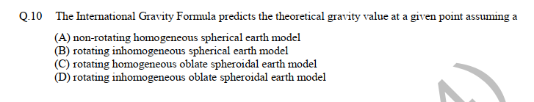
GG: Geology and Geophysics
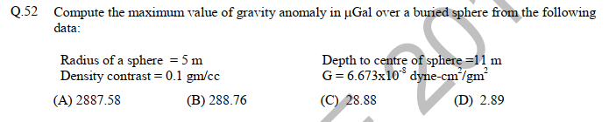
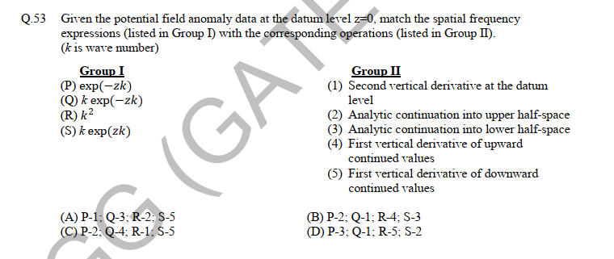

GATE-2015 GEOPHYSICS

21. Considering the Airy isostatic compensation for a mountain having elevation of 2.0 km above the mean sea level at a point P, the thickness of its root below P would be
…….km (consider densities of crustal rocks and upper mantle as 2.7 $gcm^{-3}$ and 3.3 $gcm^{-3}$ respectively).

Correct answer: 9

85. The Bouguer anomaly obtained after applying all necessary corrections is due to
(A) topographic undulations above the datum
(B) increase in densities of crustal rocks with depth
(C) lateral density variations
(D) vertical density contrast across Moho

87. A spherical body with Its center located at a depth of 1040 m gives a symmetric residual gravity anomaly high with $∆g_{max}=$5.2 mGaI. If the same anomaly were to be obtained over a 2-D horizontal cylinder, the depth to the center of the horizontal cylinder (in m) is………..

Correct Answer: 800

GATE-2016 GEOPHYSICS

7. According to Airy's model, gravity anomalies for fully isostatically compensated topography are characterized by
(A) negative Bouguer anomaly and positive free-air anomaly
(B) positive Bouguer anomaly and negative free-air anomaly.
(C) zero Bouguer anomaly and negative free-air anomaly-
(D) positive Bouguer anomaly and zero free-air anomaly

32. The value of free-air correction (assuming sea level as datum plane) at an elevation of 150 m is ………………mGa1.

Correct Answer= 46.2:46.3

33. A spherical cavity of radius 8 m has its centre 15 m below the surface. Ifthe cavitv is full of sediments of density $1.5x{10}^{3}$ kg/m and is in a rock body of density $2.4x{10}^{3}$ kg/m the maximum value of its gravity anomaly is …….. mGa1.

Correct Ans: 0.05:0.05; -0.06—0.05
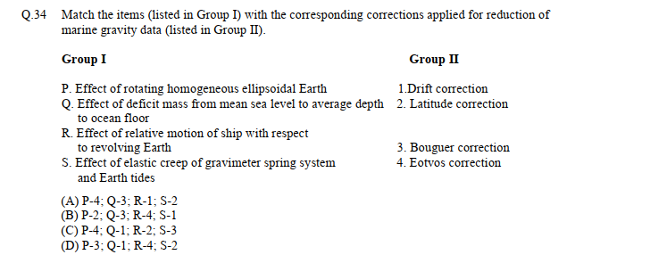

Correct Ans: B

GATE-2017 GEOPHYSICS

16.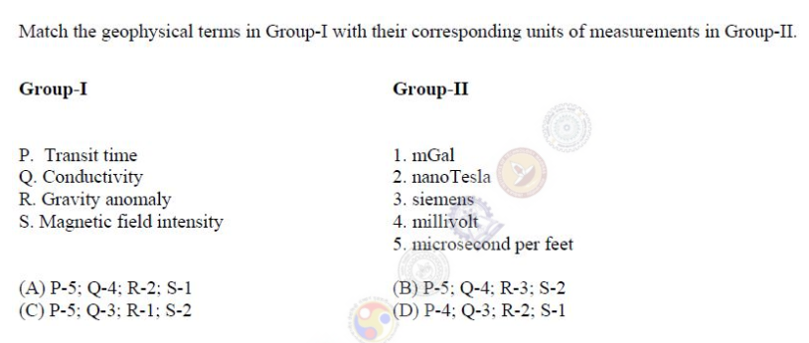

Correct answer: C

18. The normal gravity formula (for e.g. GRS80) is a function of
(A) geocentric latitude.
(B) geodetic latitude.
(C) longitude.
(D) altitude.

57.Consider a geological body buried at the equator at a certain depth. If the same body were to be buried at the North pole at the same depth. how would the gravity and magnetic field responses measured over the body differ? Assume the same magnetic susceptibility and density contrasts. (Consider only geomagnetic induction).

(A) Both gravity and magnetic field responses do not change.
(B) Both gravity and magnetic field responses change significantly.
(C) Gravity field response changes significantly but magnetic field response does not change.
(D) Gravity field response does not change but magnetic field response changes significantly.

58. Given the Bouguer density of 2.8 g/cc. the Bouguer correction for a gravity station at an elevation of 30 m above the datum is ………mGals. (Use pi=3.14).

Correct answer: 3.3 to 3.7

GATE-2018 GEOPHYSICS

15. The geoid can be best defined as

(A) an oblate spheroid that best approximates the shape of the earth.
(B) a surface over which the value of gravity is constant
(C) the physical surface of the earth
(D) an equipotential surface of gravity of the earth.

21. Which one of the following corrections is always added during reduction of the observed gravity data?
(A) Latitude
(B) Free-air
(C) Bouguer
(D) Terrain

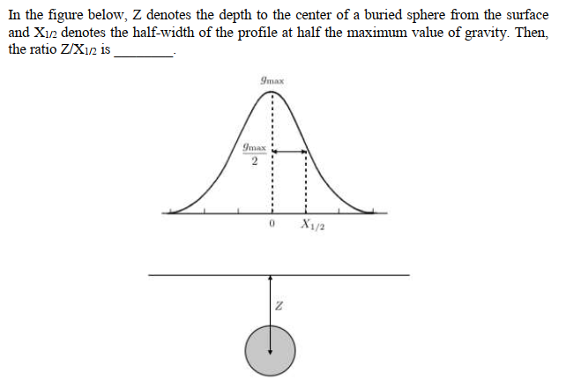
72.

Correct Answer : 1.2 to 1.4

73. Two survey vessels with shipborne gravimeters are cruising towards each other at a speed of 6 knots each along an east-west course. The difference m gravity readings of the two gravimeters is 63.5 mGal at the Point at which the survey vessels cross each other. The latitude along which the survey vessels are cruising is……ᵒN

Correct Answer: 44.5 to 46.0

GATE-2019 GEOPHYSICS
5. The acceleration due to gravity (g) begins to fall sharply towards the centre of the Earth from the discontinuity.

(A) Conrad
(B) Mohorovicic
(C) Gutenberg
(D) Lehmann

15. Which one of the following is only a conection and not a reduction in the computation of gravity anomalies with respect to a datum?
(A) Free air
(B) Bouguer
(C) Terrain
(D) Isostatic

21. Assuming Airy isostatic compensation, the depth to the Moho from a point located 2 km above the mean sea level is…….km. (round off to I decimal place).
(The depth of compensation T for the crust at mean sea level is 30 km, the density of crust and upper mantle are 2.67 gm/cc and 3.30 gm/cc, respectively).

Correct Anwer: 40.3 to 40.6

71. In gravity anomalies, the 'Indirect effect' mainly arises from……
(A) the sources outside the area of investigation
(B) improper instrument drift
(C) effect of mass lying between the geoid and ellipsoid
(D) short-wavelength uncompensated masses in the subsurface

75. Which one of the following statements about the gravity anomalies on land is CORRECT?
(A) Free-air and Bouguer anomalies are always positively correlated with elevation
(B) Isostatic anomalies are not useful to understand the crustal heterogeneities
(C) Vertical derivatives are used to enhance the gravity effects of deep-seated bodies
(D) X-horizontal gradient ($\frac{∂g}{∂x}$ )map enhances / sharpens anomalies of bodies trending N-S (X-East, Y-North, Z-downward).

77. In an abandoned mine-site, three hollow spherical cavities are located below the surface centered at depths of 50, 100 and 150 metres. Assuming that residual gravity is low due to each one of these cavities are small 0.05 mGaI), do not interfere and can be detected by the gravimeter, the most ideal (largest) grid spacing for carrying out the gravity surveys in order to correctly delineate these cavities is ……..metres. (round off to the nearest integer).

Correct Answer: 38 to 39
REPORT TITLE


25.
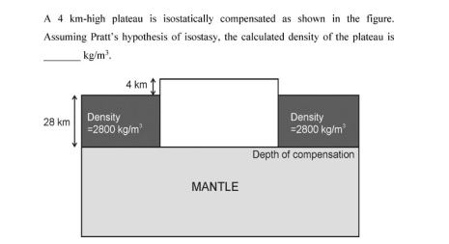

1. Which of the following models is the international gravity formula based on?
- Non-rotating homogeneous spherical Earth model
- Non-rotating homogeneous oblate spheroidal Earth model
- Rotating homogeneous oblate spheroidal Earth model
- Rotating inhomogeneous spherical Earth model
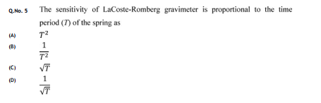
REPORT TITLE
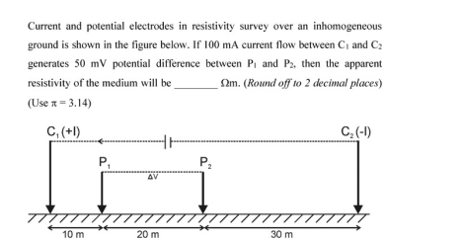
21.

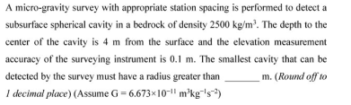
27.

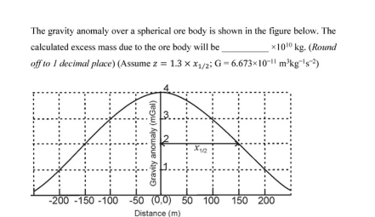
28.

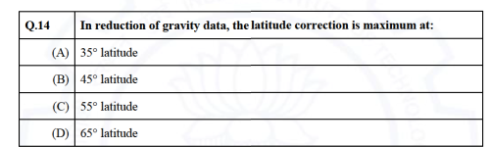
2021

